Nathaniel Matthews-Trigg
Associate Director of Climate and Disaster Resilience

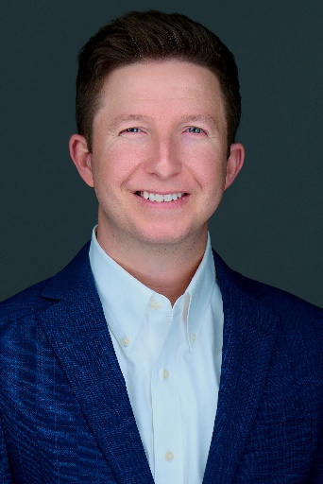
Americares Associate Director of Climate and Disaster Resilience Nathaniel Matthews-Trigg, MPH, CEM, is part of a team that develops innovative global programming that prevents or addresses the health impacts of climate change.

He works closely with health providers and clinic staff serving low-income and uninsured patients, ensuring they have the resources to protect the most vulnerable patients from hurricanes, wildfires, flooding, extreme heat and other weather events intensified by climate change.

Americares supports over 4,000 health centers worldwide with transformative health projects, medicine, and medical supplies, improving the health of millions of people affected by poverty or disaster every year.

Matthews-Trigg plays a pivotal role in Americares growing portfolio of climate resilience and preparedness programs, including the Climate Resilience for Frontline Clinics Toolkit and the Climate Health Equity for Community Clinics Program—both collaborations with the Center for Climate, Health, and the Global Environment at Harvard T.H. Chan School of Public Health (Harvard Chan C-CHANGE).

Matthews-Trigg joined Americares in 2023 after several years of working in climate and health research, and health care emergency management. Prior to joining Americares, he served as both an operational planner and exercise coordinator for Northwest Healthcare Response Network, the health care coalition for western Washington state. He supported the development and implementation of the World Health Organization’s Global Heat Health Information Network while interning for the World Health Organization’s and World Meteorological Organization’s Joint Office for Climate and Health and was a founding member of the New Mexico Health Professionals for Climate Action organization. Matthews-Trigg is an affiliate instructor with the University of Washington’s Center for Health and the Global Environment.

He earned a bachelor’s degree in psychology from the University of California and a Master of Public Health from the University of Washington. He is also a Certified Emergency Manager through the International Association of Emergency Managers.

